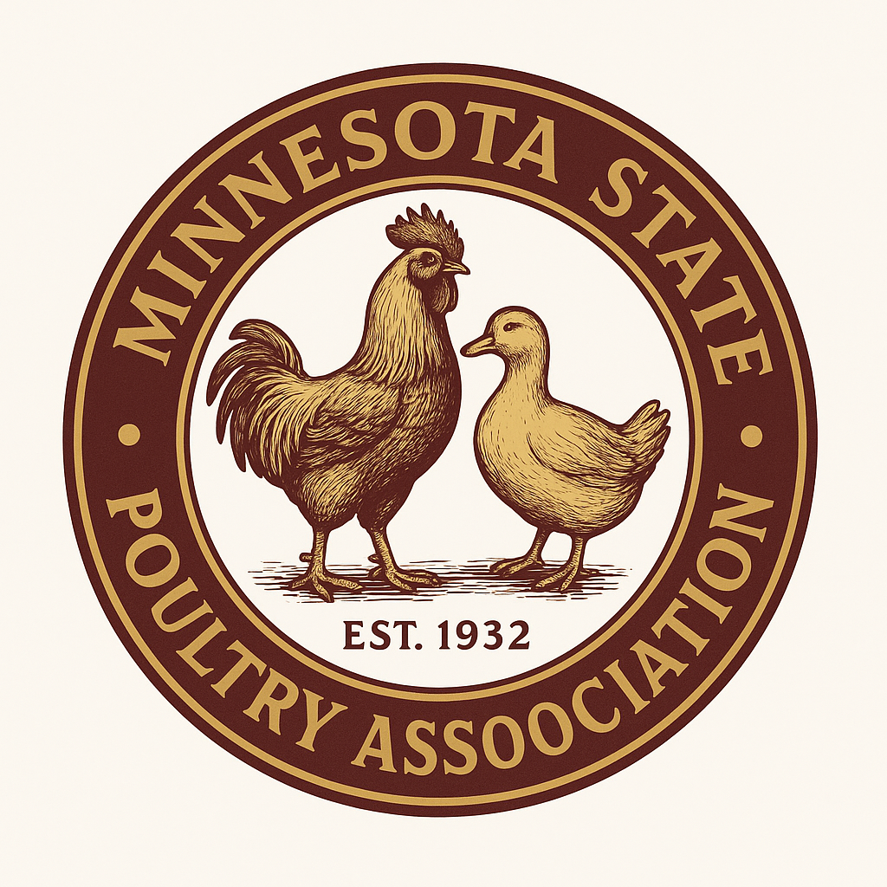
2026 MINNESOTA STATE POULTRY ASSOCIATION ENTRY FORM
Send mail in entries to Nicole Peters 5605 Grimms Rd, Reedsville, WI 54230. 920-242-1412, npeters@tm.net
Entry deadline October 2, 2026
Open entry fee is $5.00 per bird. Double coops are $10.00. Trios are $15.00. Junior entry fee is $4.00 per bird. Double coops are $8.00. Trios are $12.00
Requirement from Minnesota Board of Animal Health for out of state exhibitors: Need to call for an exhibitor’s permit number at 1-320-231-5170 or online at https://www.bah.state. mn.us/single-move-request-form-poultry
Exhibitor Name:
Address:
City, State, Zip Code:
Email:
Phone:
Open show ______ Junior show _____
Showmanship ____ 9 years and under ____ 10-14 years ____ 15-18 years ____

# Birds
# Double coops
# Trios
Club dues ($10)
Total Fees

Bantam or large fowl | Variety and Breed | Cock | Hen | Cockerel | Pullet | Old Trio | Yong  Trio

